MadMath Idle (Mental Math Builder Java Port)
  - Preliminary Design Document
  - Jenul Ferdinand, 22/08/2021.
I am going to make port my mental-math-builder game into Java, my goal is to make it as 1:1 as possible which will be a challenge for me since I am a lot more fluent in Game Maker Language. The Game Maker engine is packed with useful features like the sprite editor, and room editor allowing you to make your work look beautiful with ease.
The Game Maker build acts as a prototype for this major project. I will need to rewrite the code in Java, learn along the way, and figure out how to make the window look elegant and responsive.

Interface Design
Using the mental math builder formula, the user must be able to recognise the math question and type out their respective answer. If the answer is correct, they are rewarded with points, which act as a currency to buy purchase upgrades for a benefit.

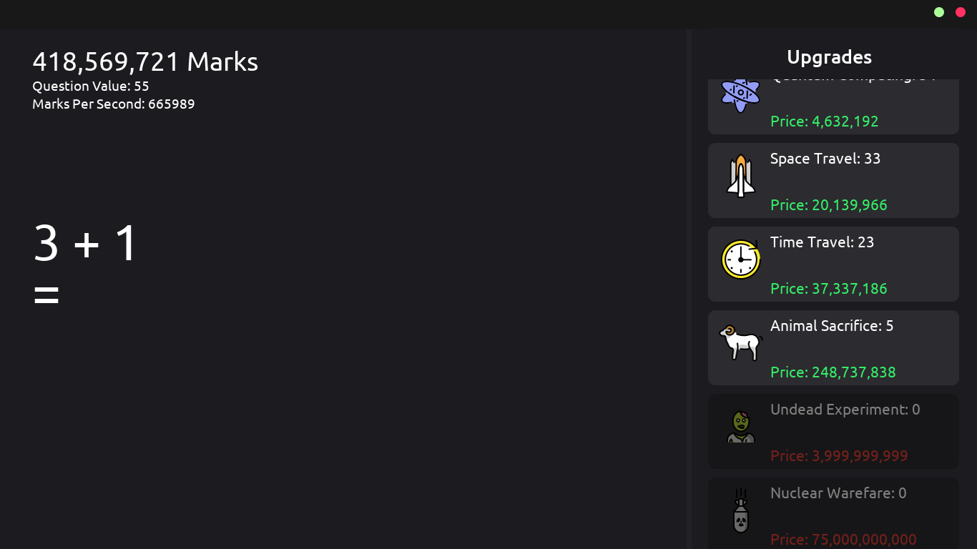
MadMath Idle (My Mental Math Builder Game)

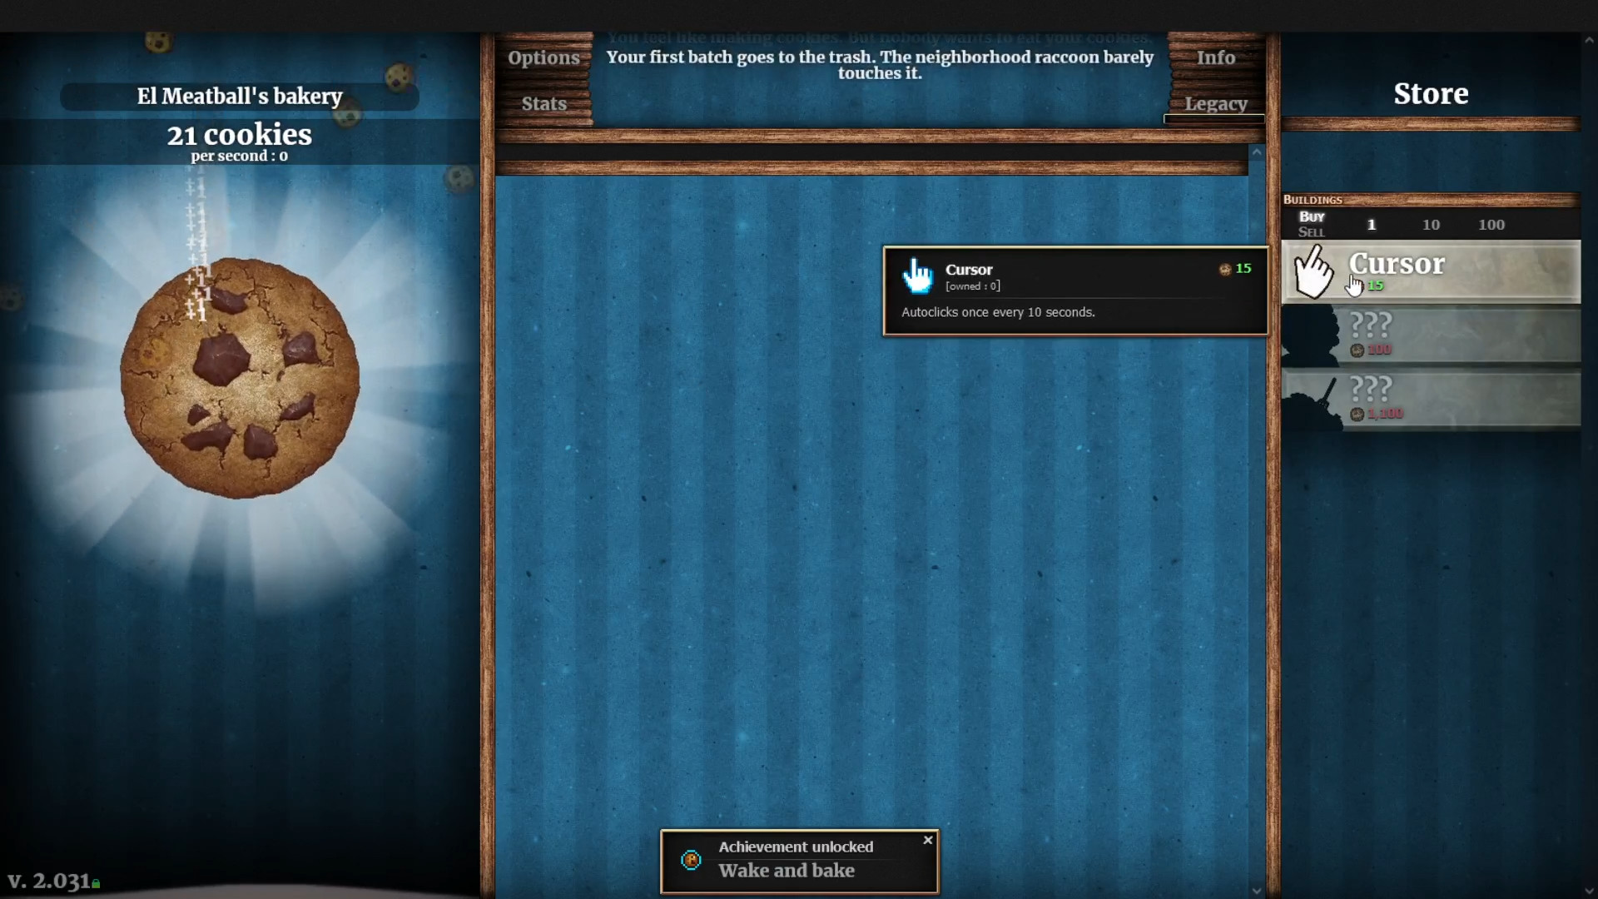
Cookie Clicker (Orteil).

- The left side of the window will be the question-and-answer area.
- The right side will contain the upgrades which is a scrolling area. Hovering over the upgrades will bring up a tooltip containing information about its parent upgrade.
- The purpose of the whitespace in the middle is unclear as of now, but as development progresses, I will think of something to add there. Some ideas I have: more user interface elements, achievements, saving and loading, progression, etc.

Class Diagram
Class | Game | Upgrade | Tooltip (Upgrade Child)
Attributes  (variables) | total_marks  marks_per_second  question_value  upgrades(array) | icon  label  cost  description  marks_per_second  question_value  quantity | - label  - cost  - description  - marks_per_second  - question_value  - quantity
Behaviours  (methods) | update  questionCheck  incrementMPS  createUpgrades  randomArithmetic  randomiseValues  stringLargeNumber  stringThousands | Upgrade  getMPS  getQV  getDescription  getLabel  createTooltip | Tooltip

I will update the class diagram as I work on the project.

Assets
Images
- Upgrade button image
- Emoji sprites
- Titlebar
- Titlebar icons
- Tooltip image
Text
- Google fonts via API?
- Fonts

